Payroll, Shifts, Loans and Leaves

A White Paper

{date}

Contents

1. Introduction 2
2. Business Case 2
3. Problem Statement v/s Proposed Solution 2
4. Product Overview 3
5. Results / Conclusion 24

WHITE PAPER SAMPLE

Introduction

Payroll involves performing many tasks to ensure accurate and timely paychecks and payroll tax and record-keeping compliance. These duties cannot be rushed, and they should be performed with painstaking detail. Otherwise, erroneous paychecks and improper payroll tax and record-keeping procedures can result. The former situation can cause employees to become upset; the latter two situations can cause penalties from the Ministry of Labor and other involved government bodies. Consequently, when doing payroll, apply a step-by-step process.

Business Case
Payroll components and their respective rules and formulas can be defined in the system. An employee can raise Leaves and Loan application using Employee Self-services portal. Wage Protection System (WPS) and CTC matrix is accommodated within the system as per the laws mandated by the government. Various payroll reports can be generated using our report builder.

Problem Statement v/s Proposed Solution
Problem | Solution
Applying for leaves and loans using the traditional methods of Word and excel is difficult to maintain for records | Employee self-service is a common portal between the employees, HR and managers to apply and approve various leaves and loan applications
Maintaining daily attendance in excel or manually in the system is quite a pain | Option to import attendance, integrate it with biometric device and manually maintain the entries gives a lot of flexibility to the users
Payroll runs are very critical and any mistakes in the calculations affect the Net values | Option to preview the calculated values for each payroll run before saving it gives a chance to check for errors. Approvals can also be set up to adhere to four-eye principle
Sometimes integration with FA gives some errors | The payroll runs are always prechecked before saving and the FA systems can be seamlessly integrated to post payroll entries
Manual calculation of End of services | During EOS, an employee’s salary structure as well as pending leaves, loans and other components are automatically populated and sent for approval

Product Overview
Centra HCM provides end-to-end payroll solution as well as integration with any third-party Finance system for postings. There is also a provision for importing the data from excel.
Payroll components like Leaves, Loans, Earnings and Deductions applicable to the whole organization are maintained and the rules and calculations of each component are then defined within the system. These rules are set in accordance to the laws mandated by the government. For each component, revision history can be maintained to track the changes made in the settings.

- Earnings preferences
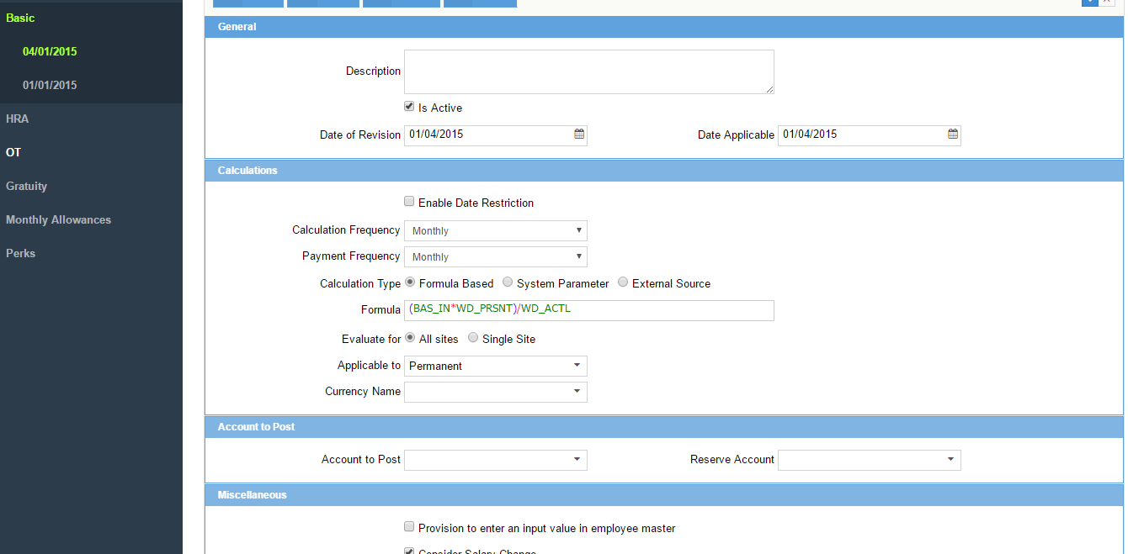

- Leave preferences
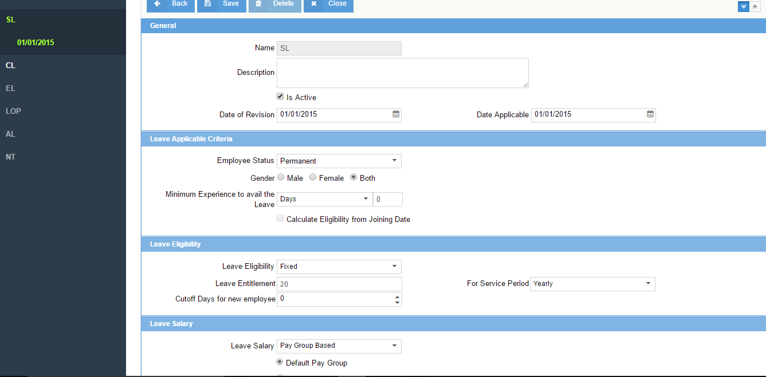

- Loan preferences
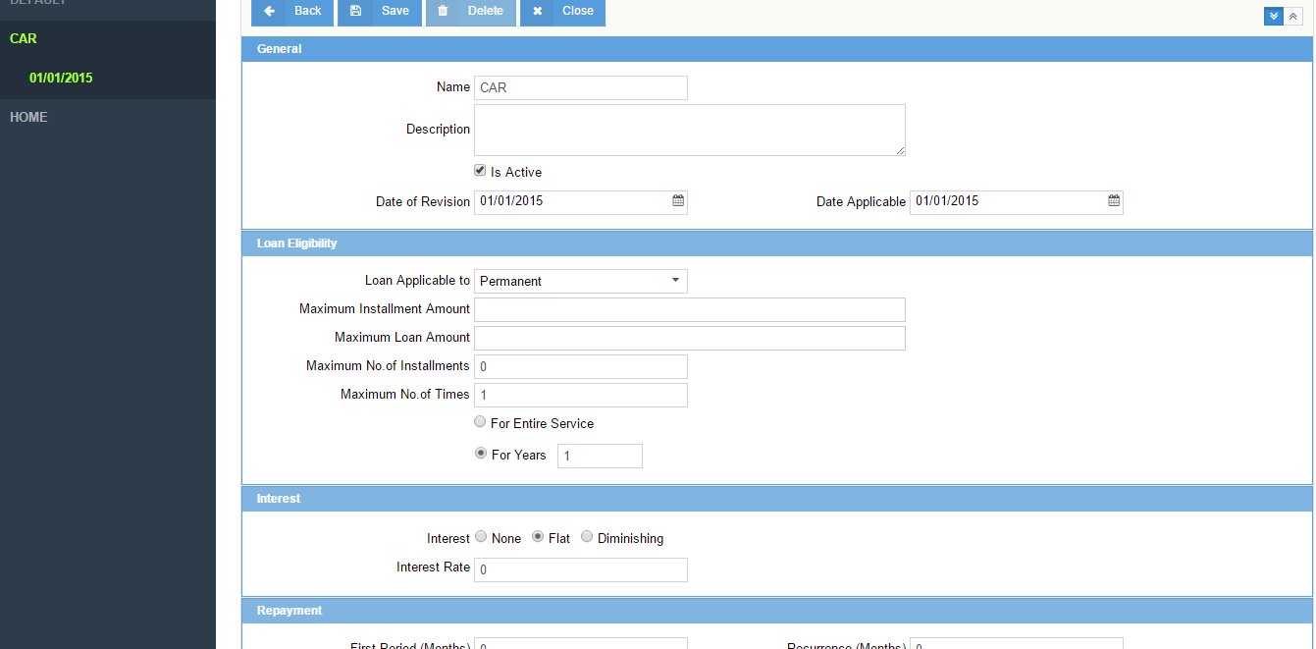
Payroll frequency settings are defined.
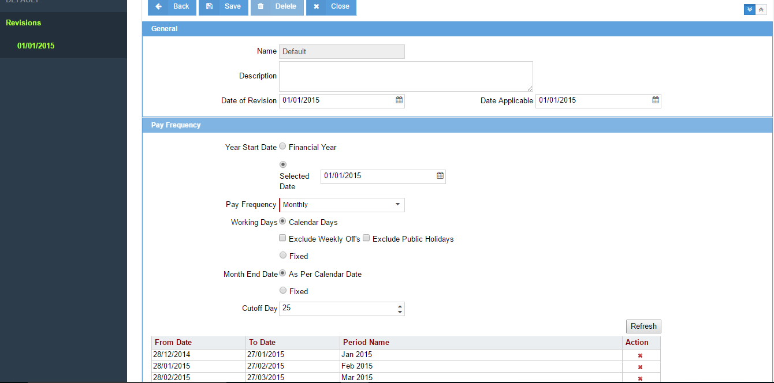

Once these settings are defined, each of these templates are mapped in Pay Group and some additional settings for that paygroup are defined. This Pay Group is the connectivity between the employee and the payroll.
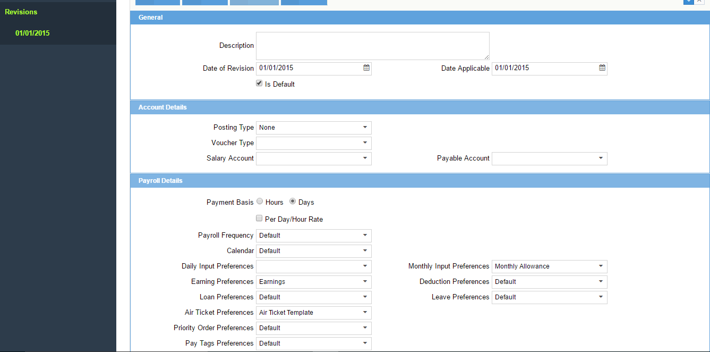

In order to handle other miscellaneous allowances which have to be payed adhocly either on a daily or a monthly basis an option of Daily Input and Monthly Input can be used in the system whose creation process is the same as that of other components.
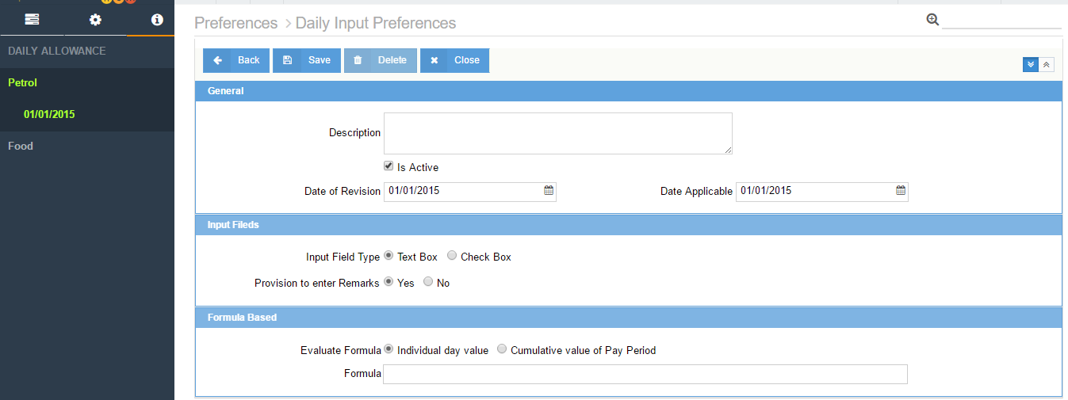

For UAE, as per the government laws, Gratuity must be payed out to every employee based on certain criterias like years of experience and number of years served in the organization to which certain slabs are defined. Centra HCM is compliant to the laws and has the provision to define these parameters. The screens and fields are flexible to accommodate to any changes in the future.
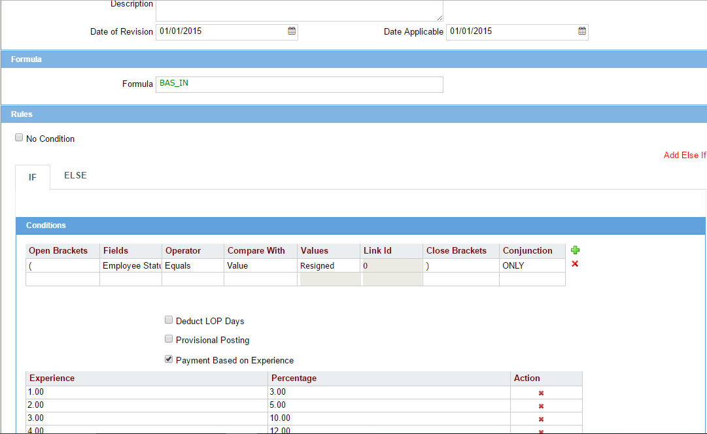
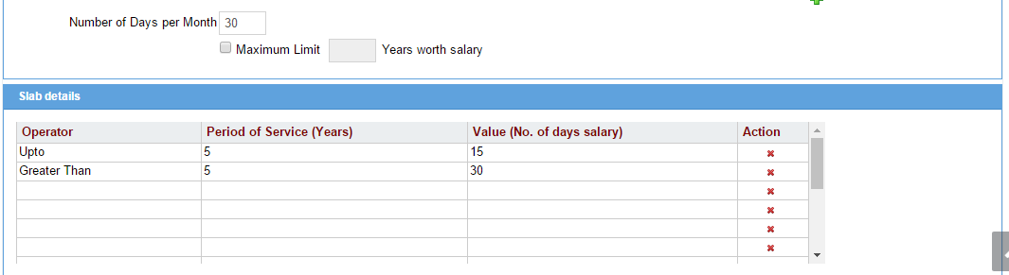

UAE specific Wage Protection System (WPS) law is also accomodated within the system where the files can downloaded in a specific format as mentioned by the government and submitted to the bank for processing through WPS.
CTC matrix has been introduced which deals with payouts based on nested hierarchies. For example, within Designation A there are three different Positions A, B and C and for each of them Payouts are different. Such kind of nesting is handled using CTC matrix where for each nested hierarchy, payout calculations can be defined.
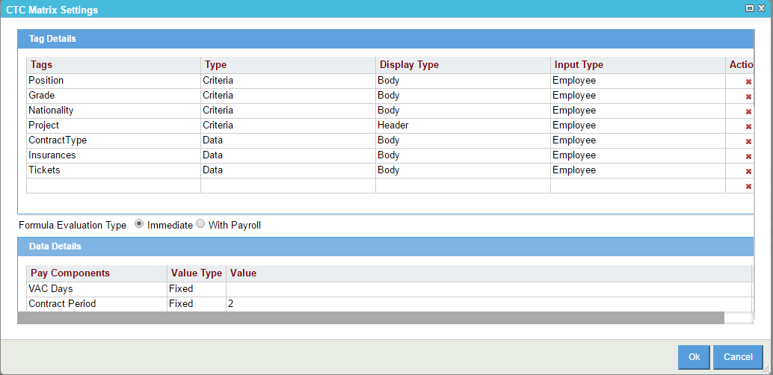
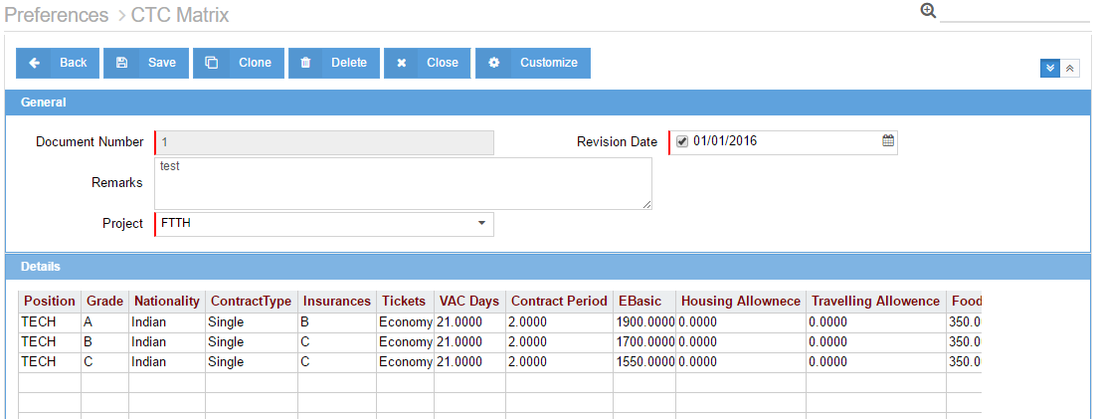
Once these settings are defined and mapped to the Paygroup, this Paygroup is mapped to each employee in the Employee Master and used for Payroll runs.

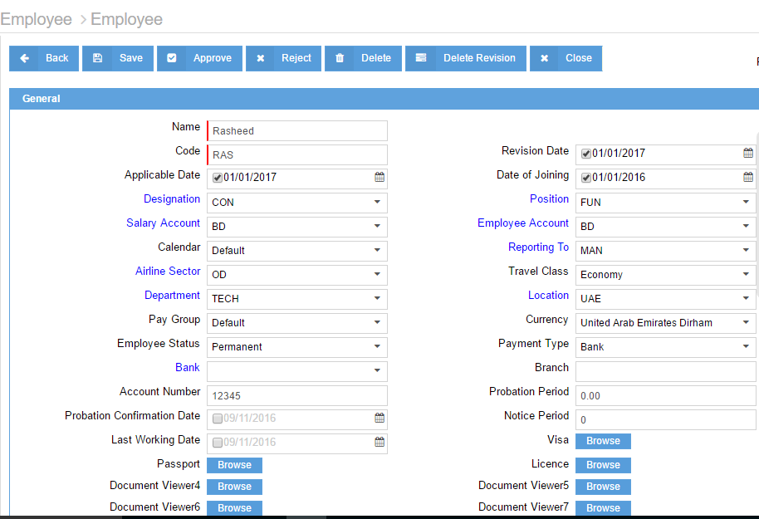

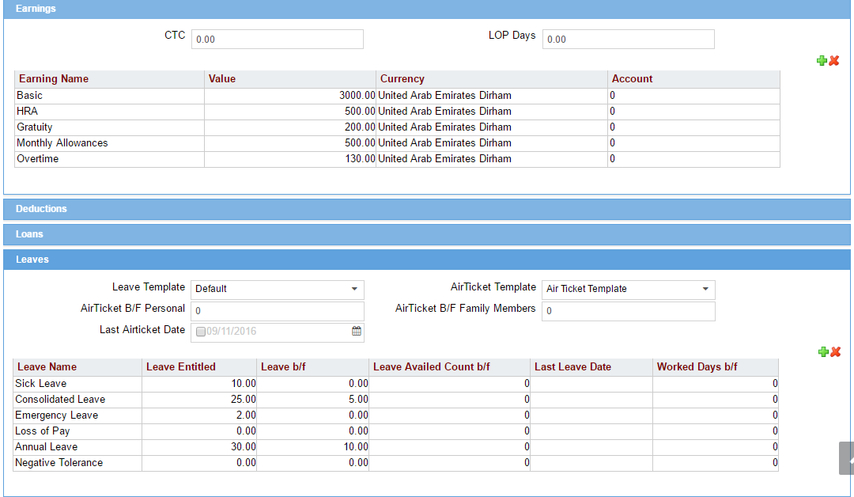

Leaves:
Centra HCM has complete Leave process including:
Leave Application
Return from Leave
Leave Settlement
Leave Encashment
Leave Adjustment, and
Leave Closing
Each screen can be configured and modified by the user admin whenever required. Rules like mandatory to fill Return from Leave forms, Leave calculations and eligibilities can be defined in settings. This Leave process is available to the employee on the Esmployee Self-service portal using which he can raise applications, encash leaves and check for approvals. Workflows can be created wherein Applications can go for appovals to the line managers. Multiple approvals can be created in a workflow.
- Leave Application – ESS
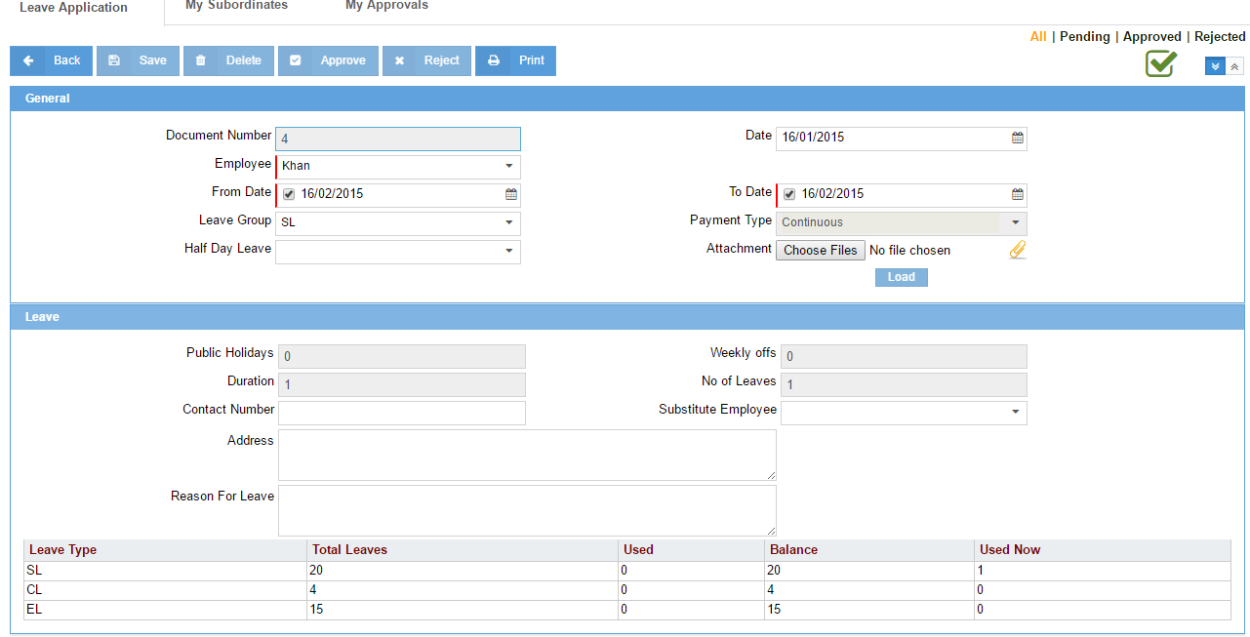

- Leave approval – ESS
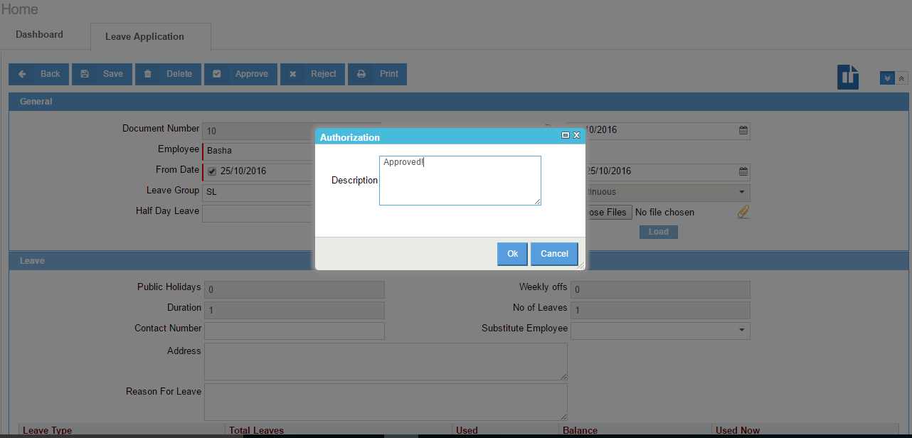

- Leave Settlement
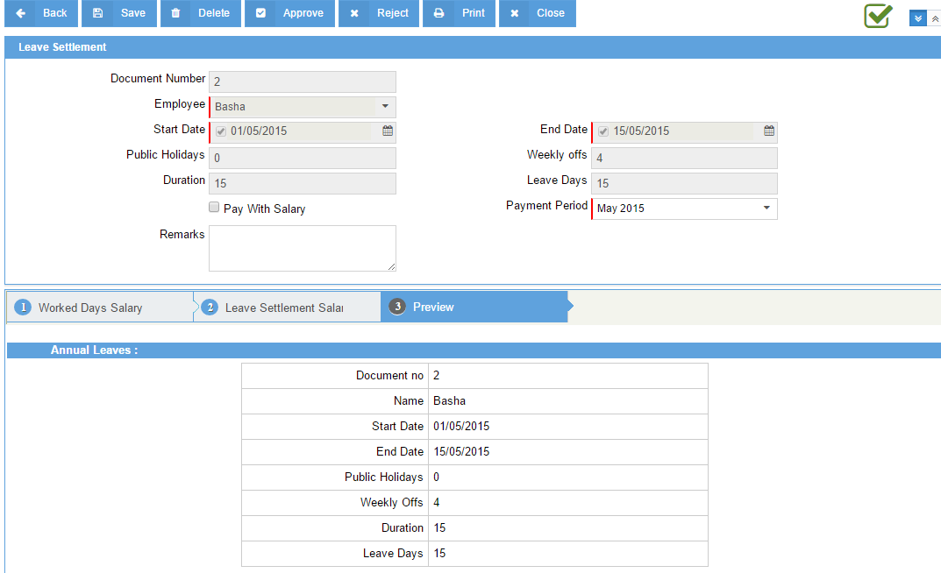

Loans:
Define the company’s loan policies and preferences to manage and maintain swift and easy access of loans. It is accessible to the employees via Employee self-services to view and communicate information between respective departments. Following is the available loan process:
- Loan application
- Loan settlement
- Loan approval
- Loan deferment

Depending on the Eligibility & Approval, Loan application form covers all basic information such as Loan amount, Loan type, EMI preference, guarantor etc. Managers can approve, reject or modify information of their employee’s information before finalizing it. User based customization of fully or partial loan settlement; loan deferment or EMI and tenure adjustments can be done with the approval & acknowledgement process.

- Loan Application
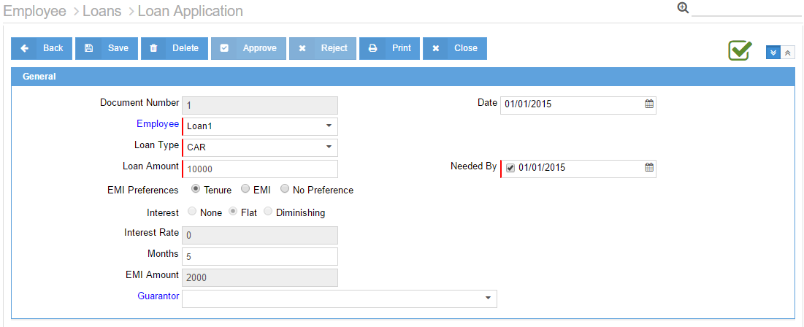

- Loan settlement
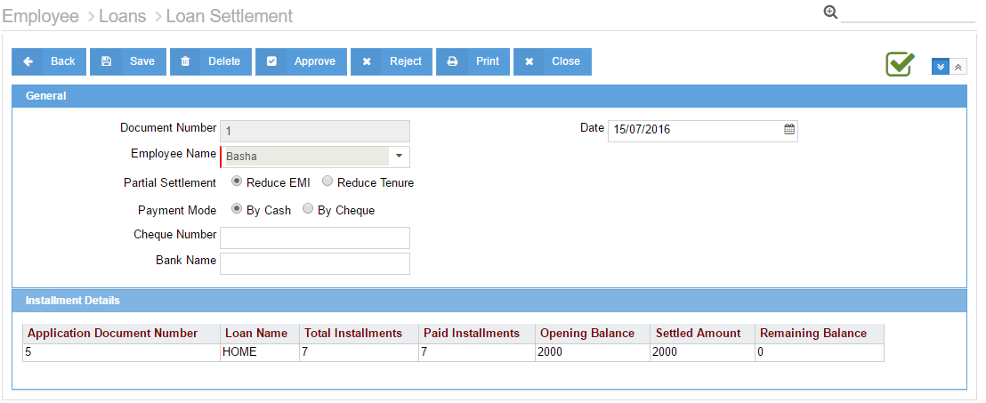

- Loan Deferment

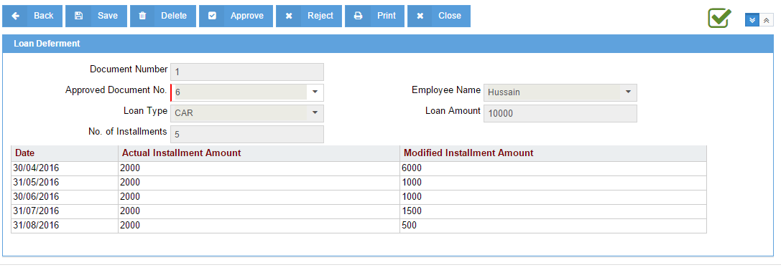

Multi-level approval process can be defined with rules on hierarchies, companies, locations, or many other situations and circumstances wherein maker-checker rules are applicable. The system can be triggered to automatically approve, reject, send back transactions based on values or conditions. Define time-based escalation procedures for unauthorized events.

- Authorization flow

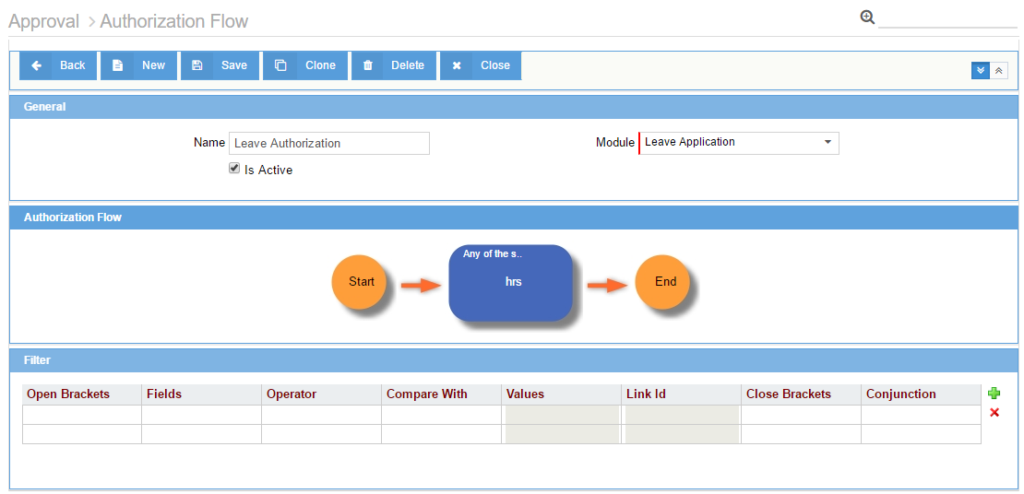

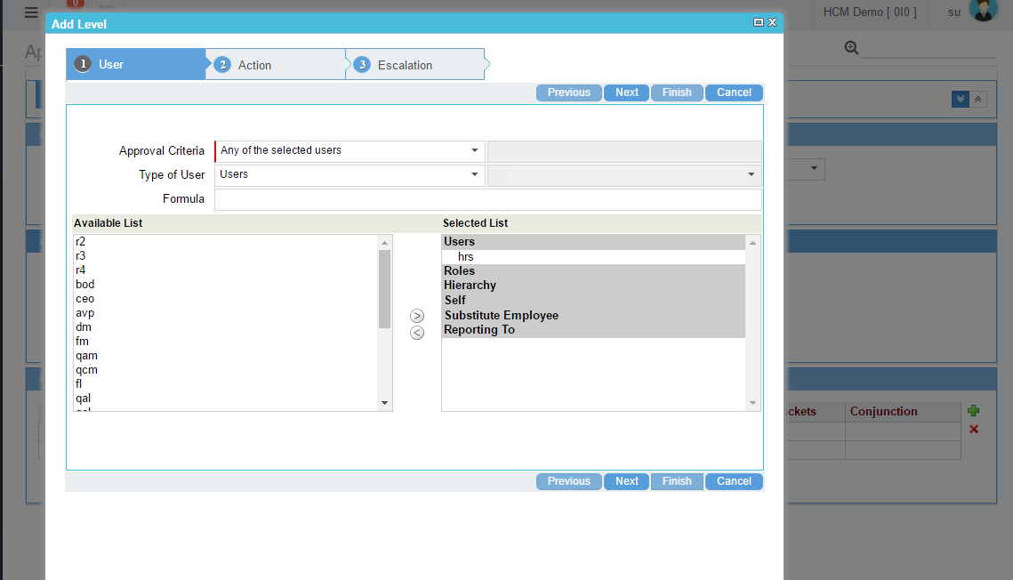

Air ticket Management includes Air ticket encashment and claims process which is available on Employee self-service. This is designed in accordance with the government laws which includes option for claiming the tickets for self or family or both depending on the rules defined in the backend. Different employees can have different set of air ticket rules and this can be handled by the system.

- Air ticket encashment
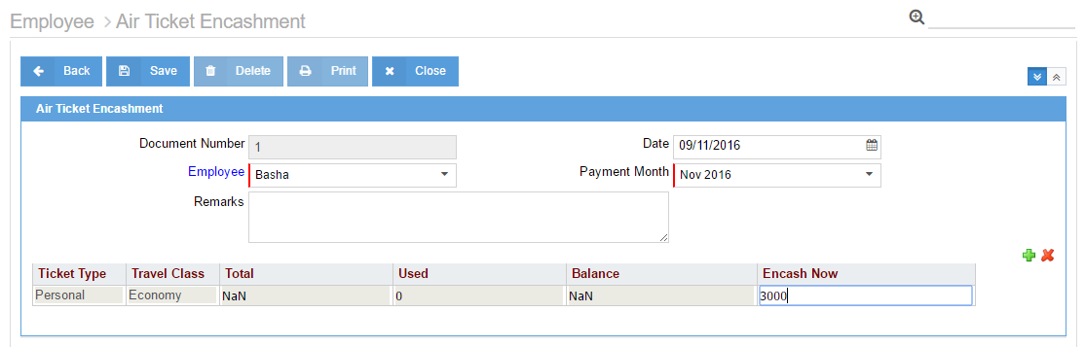

- Air ticket claims
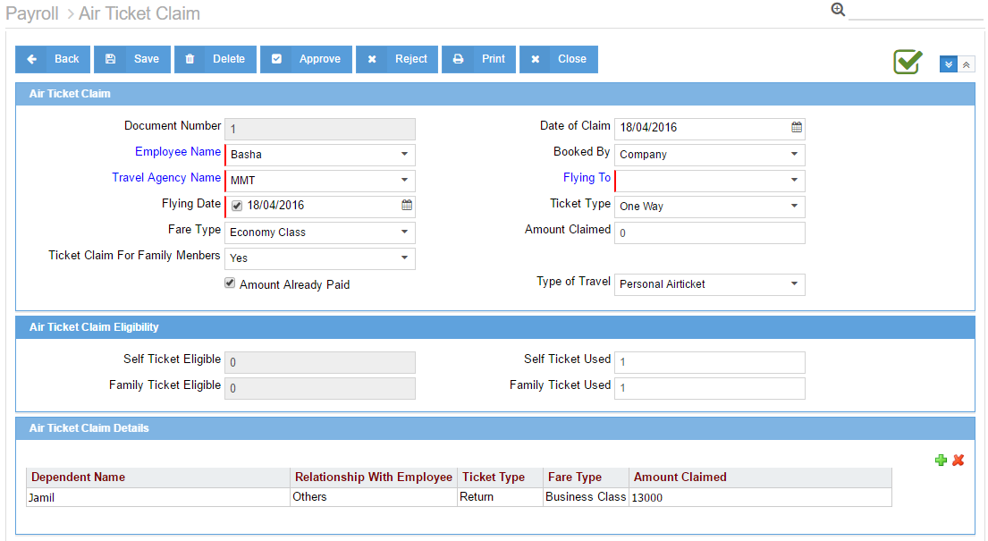

Shifts & Attendance:
Using Shifts and Attendance, organizations have a complete control over payroll management and can pay their employees on time, without having to spend days in processing and investing in heavy man power to do the periodic process.

Using Time card, Attendance can be captured & processed with different parameters such as Shifts Masters and Shift Assignments including the Start and End time of the shift and the Working hours, OT Hours (min /max), Late definition, tolerance settings etc.
- Shift Master
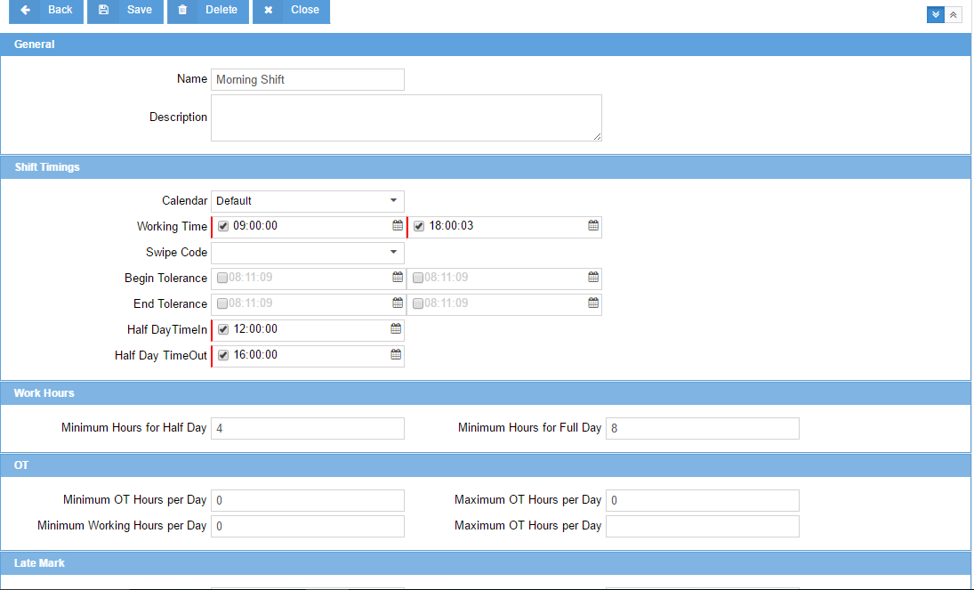

- Shift assignment
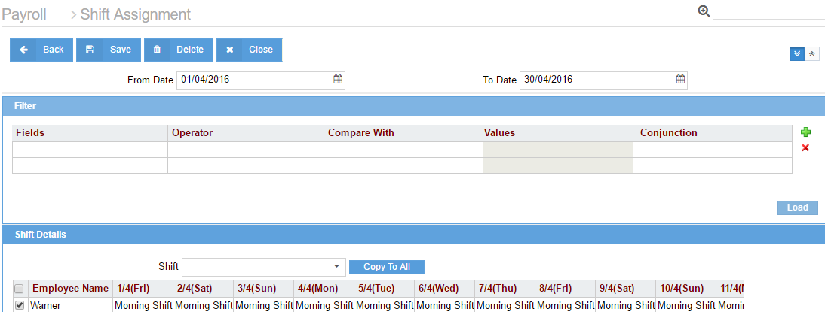

- Time card
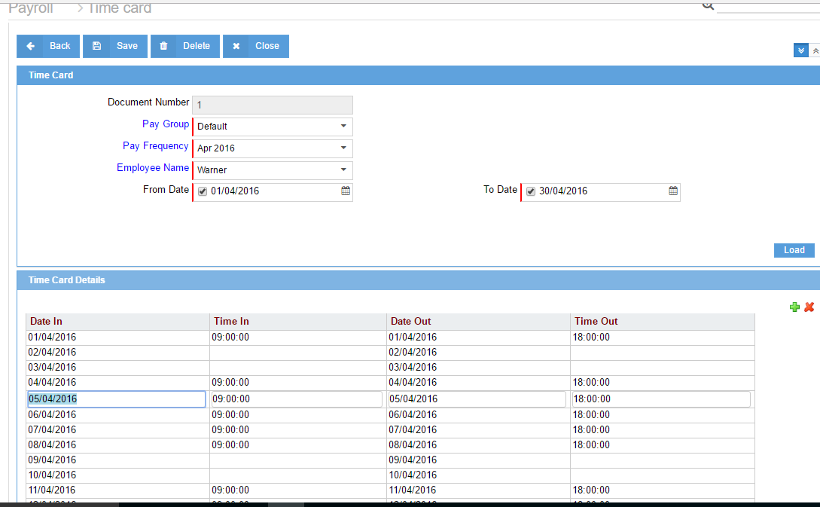

Multiple options to capture hourly, daily or monthly attendance, filtered by location & project for single or multiple employees and pay groups created in the masters. Integrate the attendance management system with any third-party devices using APIs or import existing data from the template.

- Daily attendance
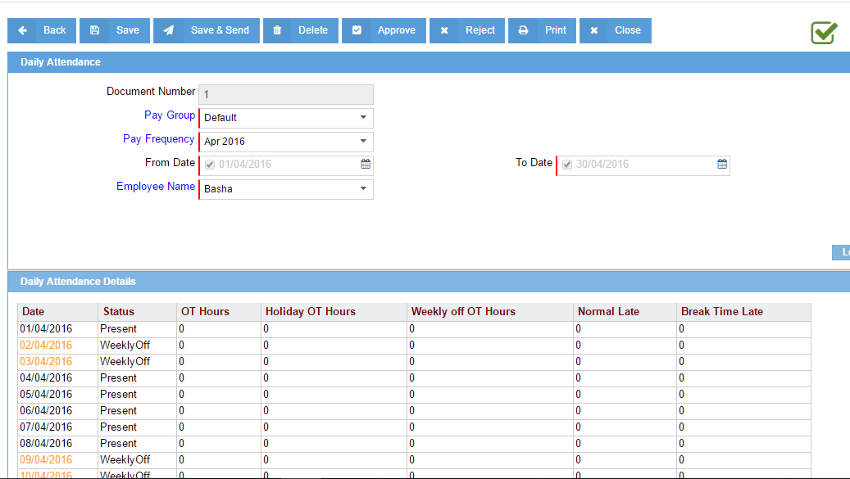
Payroll runs can be scheduled periodically by defining Payroll frequencies. Option of both single and multiple employee runs are present which allows you to run the payroll for a particular department using filters or for a whole organization or for an individual employee. These payroll entries are then posted to any third party FA system.

- Multiple employees payroll
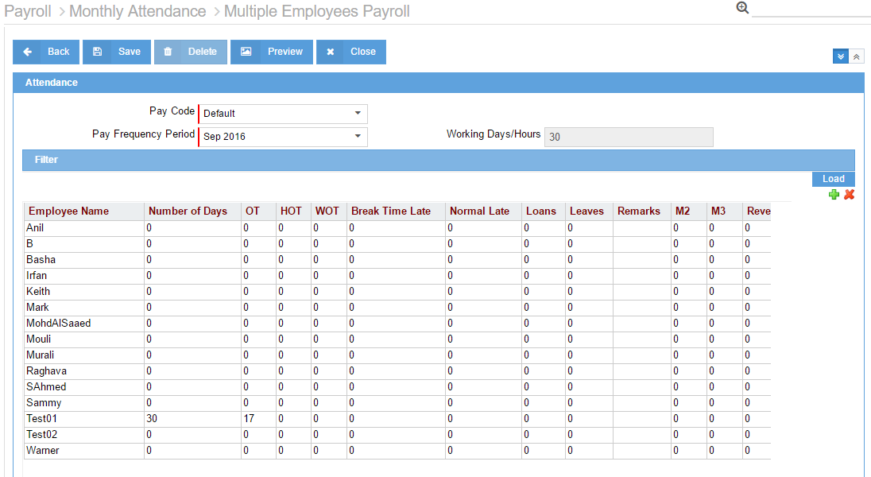
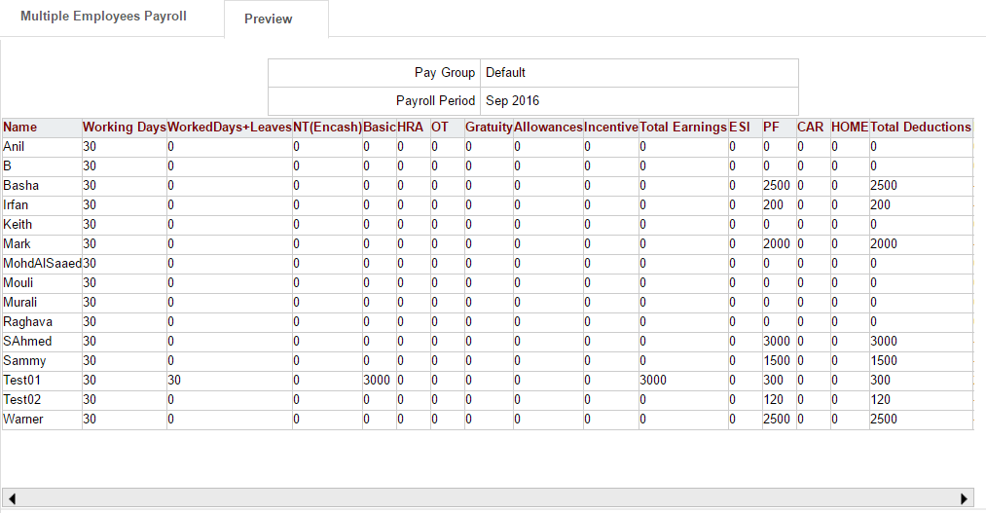

- Single employee payroll
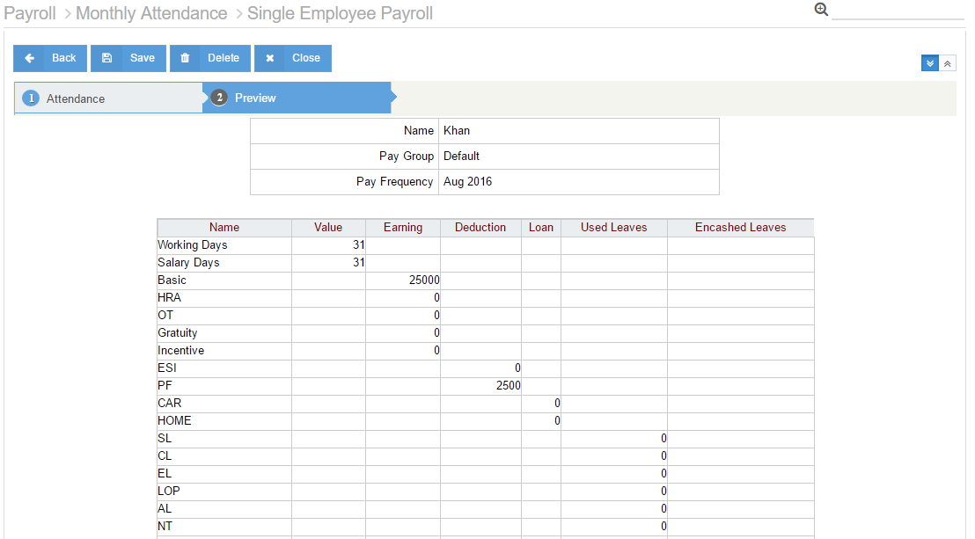

Payroll runs can be made to go through the approval process to verify that the accounts are clear and the values entered are correct.
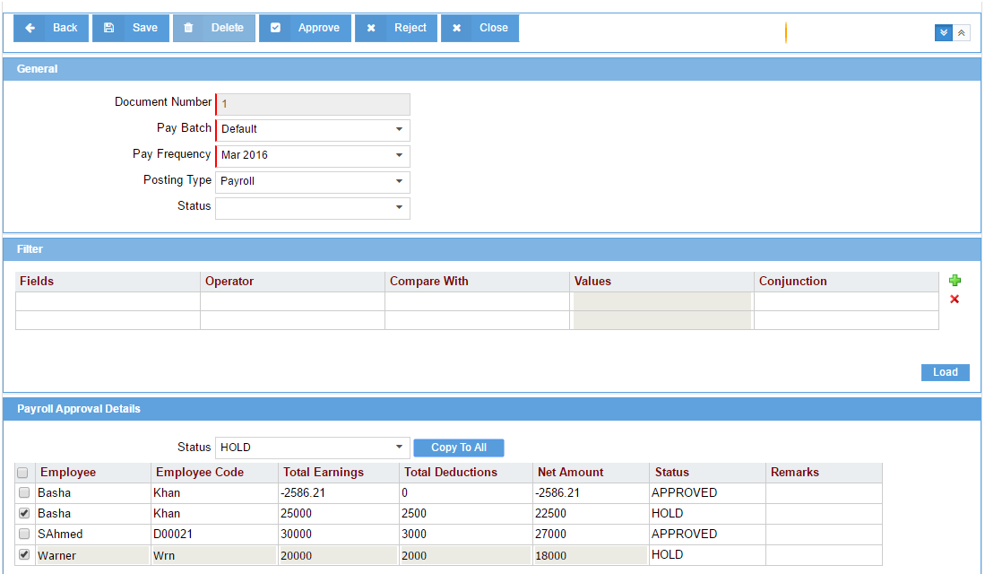
Any changes in the salary structure after posting the payroll entries to the FA system are handled through Arrears. For example, last month adjustments, increments, salary changes effective previous months can be handled using Arrears. This screen revises the applicable salary components of the payroll months already posted in the system so that an employee’s revised compensation can be stored in system from the efective date and payments can be adjusted in the upcoming months.
- Arrears
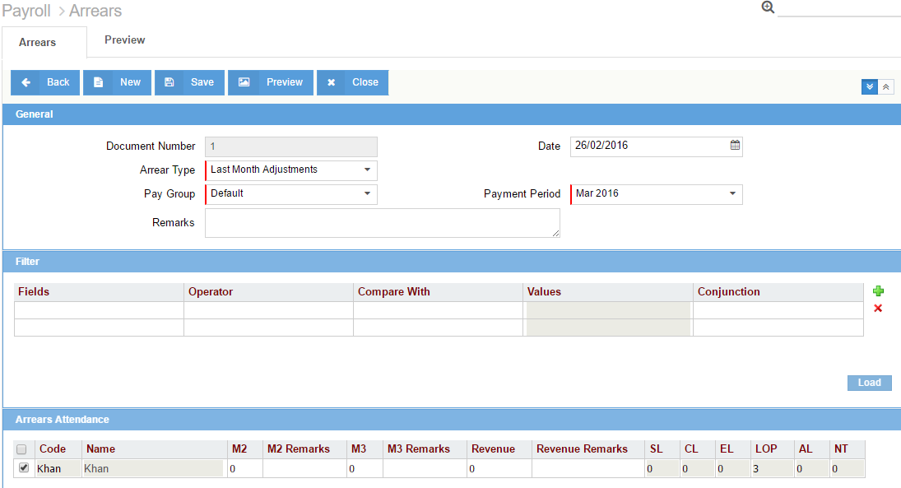
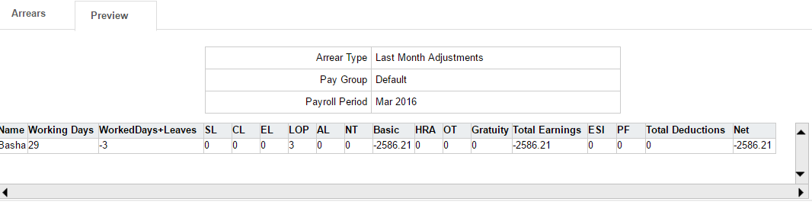

In organizations where Overtime is applicable, OT hours can be maintained in Shift master and automatically calculated during Daily attendance and Monthly payrolls. A separate OT form can also be submitted in case the actual OT hours and system OT hours do not match. Different approval levels can be generated for this form using a workflow.

End of service:
The process of employee separation is taken quite seriously by many firms and there is a dedicated department to handle employee exits from the company. Define & maintain simple yet tight process of ensuring that an employee who quits the company is exited in a structured and orderly manner. You can avail your unused leaves and settle all the pending loan amounts during the end of service settlements. You can claim your air tickets for yourself and your family based on your eligibility criteria. Expense claims settlement can also be made using different custom-defined claim types. This is settled against the full and final payments made to the employee during their end of service. Conduct exit interviews for employees through Employee Self-Services and create workflows for approvals and discussions. Settle the organization’s assets with the employee to make sure everything that is allocated is returned in acceptable conditions.

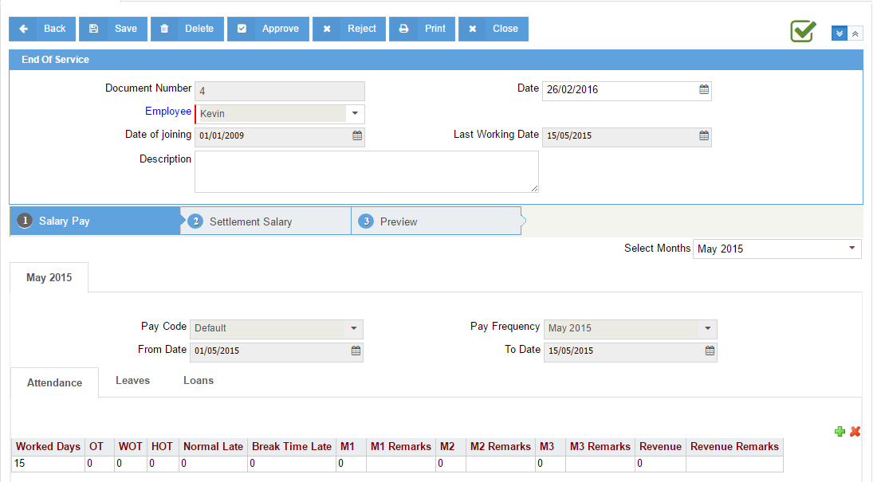

Increments, promotions and transfers help to compare an employee’s current compensation package and revise as per his appraisals or discussion with the manager. Type of salary revision is selected from the field Type like Redesignation, Officiation, Increment, Promotion or Transfer. In case more than one person is falling in the same type and has the same revised compensation package then they can be maintained together using multiple employees option.

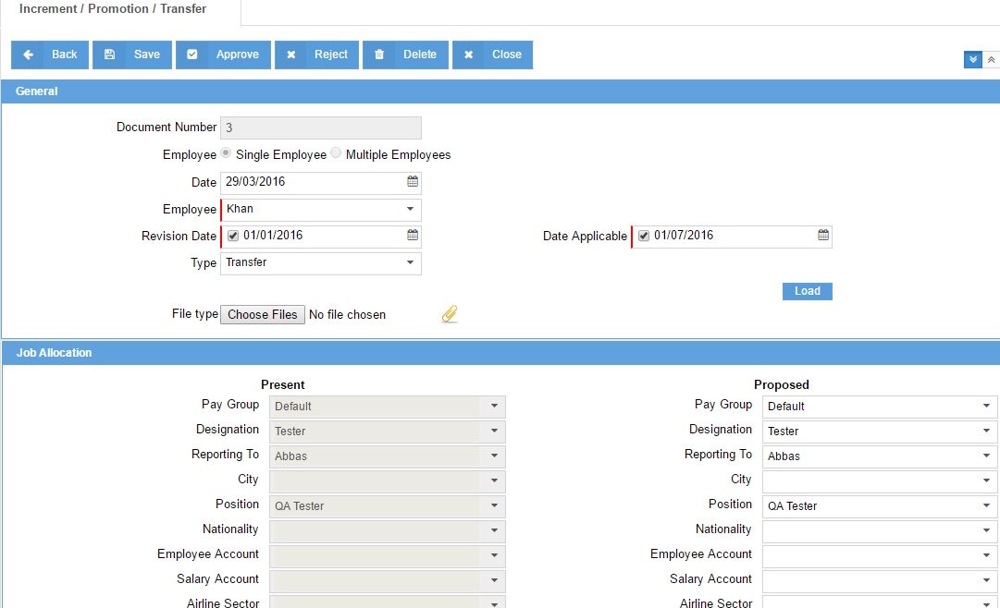
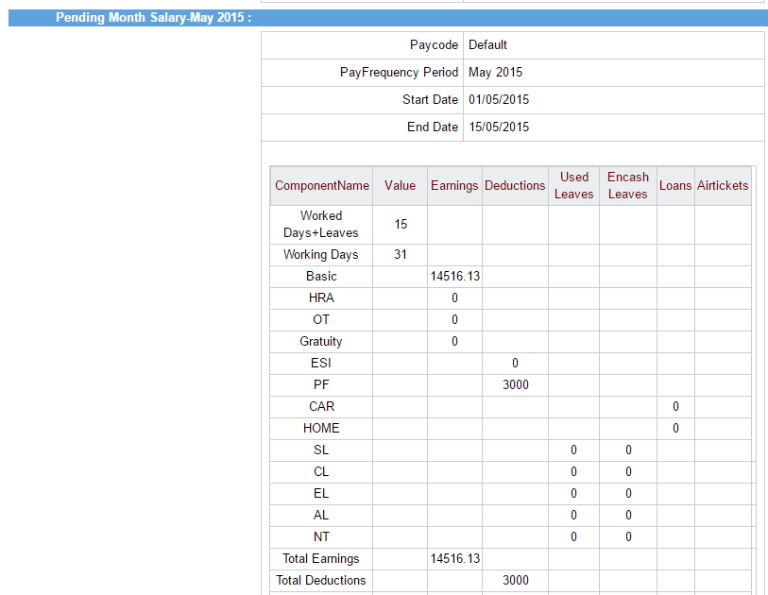
Reports:

Build, monitor and analyse multi-dimensional reports with smart analytical capabilities including color-coding, KPI definitions and graphing-engines on-the-fly. These graphs can be assimilated onto user-specific dashboards. The BI tool further allows for custom report creation using virtually any of the fields available within the module. Reports can easily be extracted into PDF, CSV, Excel and various industry-standard formats based on user rights and permissions.
Different payroll related reports like Payroll register, Paysheet, Payslips and WPS reports can be generated using our report builder. The flexibility of the report builder allows the user to customize the layout at any point of time.

- Pay sheet
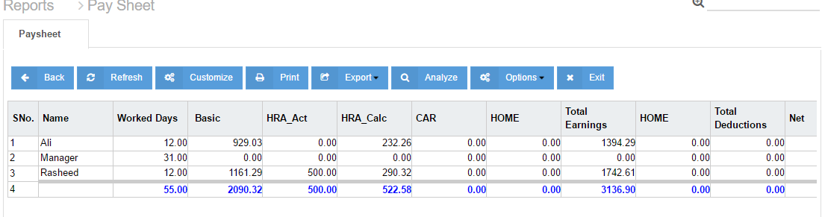

- Report customize
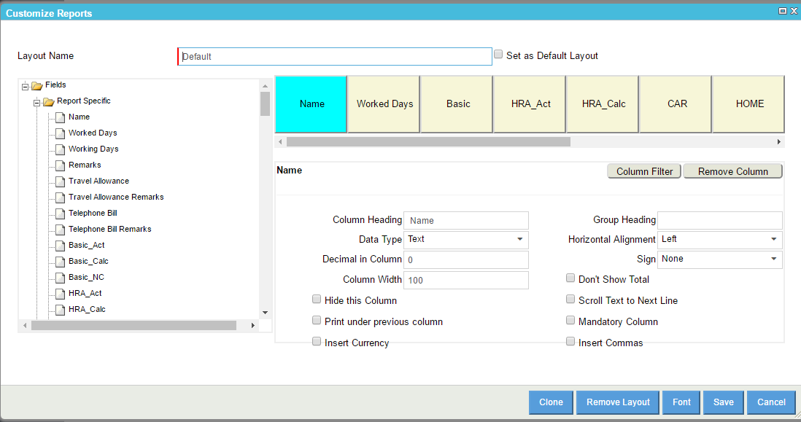

- Leave summary report
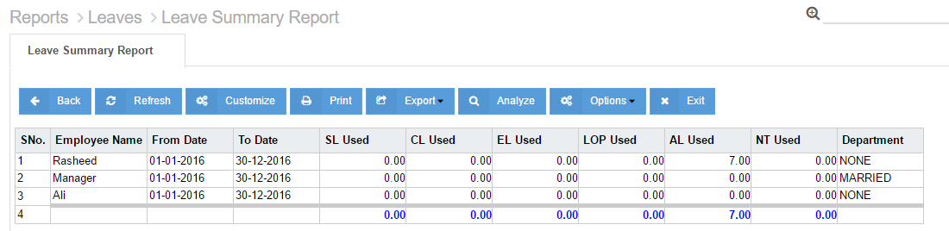

Results / Conclusion
Different payroll processes can thus be created on the Centra HCM platform. Depending on the user needs, the processes can be initiated. Employee self-services provides a communication platform between the employee and the manager.

